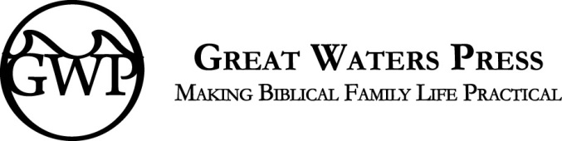
Book Inquiry
Name
Email
Street Address
City, State, Zip
Phone Number

Working Title of Your Project (This is not expected to be final, just something to call it right now.)

Genre (Non-fiction, Historical Fiction, Fantasy, Curriculum, etc)

Expected Audience (Parents, Christians, Homeschoolers, Young Adults, Couples, Singles, etc)

Do you currently have access to that audience and if so, how? (Do you speak or blog or write magazine articles or are you an expert in some area?)

Do you have a blog or website? What’s the URL? Where are you active in social media? Do you have a professional presence or only a personal one? How many followers do you have in your most active venues? (These things are not required, we can help you get started, but if you are already there, we’d like to know!)

Please share a synopsis or summary of your book. We are particularly interested in the theme (or message) you want to share.

What is your experience related to this idea?

How far have you gotten in carrying out your book? (Do you have a complete manuscript, a partial manuscript, an outline, or just an idea? If it is just an idea, this is probably not yet the time to submit a proposal.)

How long do you anticipate taking to finish your project? Give us an estimated date by which you can be ready to submit.

In order to provide authors with higher royalties long term, we work more in cooperation with authors than some other publishing firms. Are you willing within reason to read books we ask you to read, to cooperate in marketing your own book, and to participate in training to make that marketing more effective? Thoughts?

If you know any of the members of our team or our authors or have served on the Great Waters Press blogger team, please tell us how you know us and if you have any reservations about working closely with any member of our team. We are a family-owned and –operated business, so it’s important we all get along.

Because we may be working closely together, please tell us some more about you and your family and your background.

Are you are a Christian? Please tell us briefly what you believe that means. What church do you attend?

After review, if your proposal has the possibility of fitting into our upcoming plans, we will be asking you to send an outline or table of contents and at least a sample chapter to info@greatwaterspress.com. We promise not to share your manuscript outside our firm without your permission until a contract has been signed.

Please understand that we receive many more inquiries from wonderful authors than we have the means to publish in a year, so if we are unable to proceed further with your inquiry, it may be no reflection whatsoever on the marketability or quality of your work, but only our limited means. Please also be aware that we have several manuscripts in process that have not been publically announced yet. We may have a book along the lines of what you are proposing already on our schedule.

And finally, we are a family business owned by Christians. Our primary goal is to glorify God. We will not publish any material that in our view does not glorify God, tempts others to sin, or varies from orthodox Christian doctrine. We hope the books we publish will instead help others to repent and believe in Christ for salvation and encourage them to live out their faith in the real world.

By His grace alone,
Hal & Melanie Young
Publishers
Great Waters Press

